Answers for Task 1:
-- 1. CREATE DATABASE & USE IT
CREATE DATABASE IF NOT EXISTS academic_management;
USE academic_management;

Screenshot :
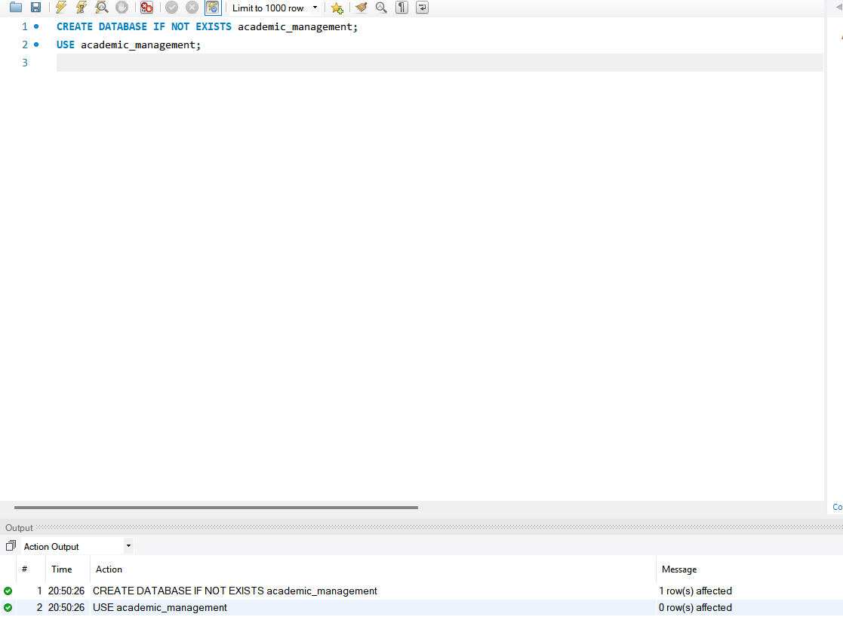
------------------------------
-- 2. TABLE CREATION (MySQL)
------------------------------

CREATE TABLE StudentInfo (
STU_ID INT UNSIGNED AUTO_INCREMENT PRIMARY KEY,
STU_NAME VARCHAR(100) NOT NULL,
DOB DATE,
PHONE_NO VARCHAR(15),
EMAIL_ID VARCHAR(100) UNIQUE,
ADDRESS TEXT
);
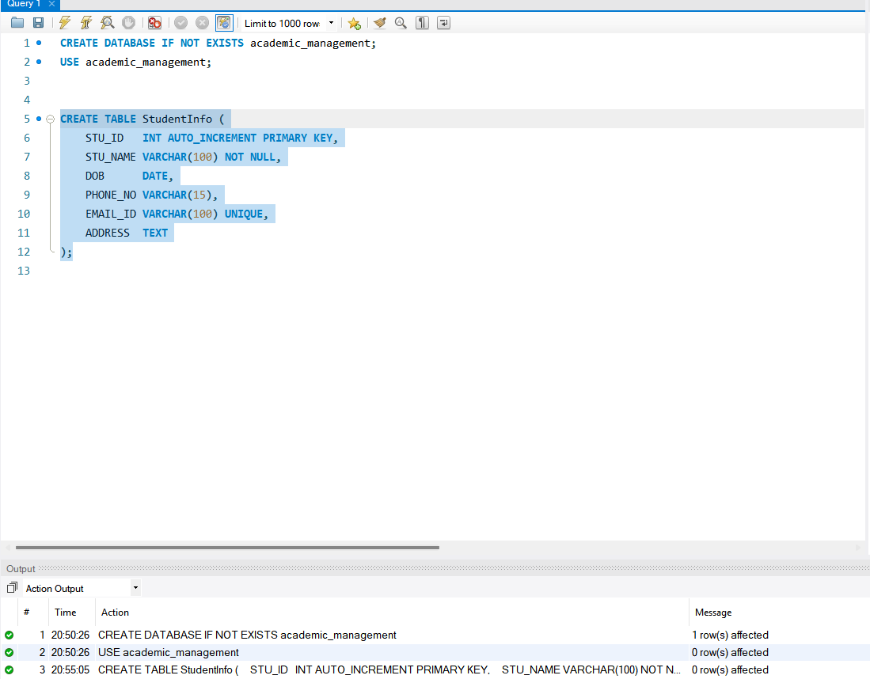
CREATE TABLE CoursesInfo (
COURSE_ID INT AUTO_INCREMENT PRIMARY KEY,
COURSE_NAME VARCHAR(100) NOT NULL,
COURSE_INSTRUCTOR_NAME VARCHAR(100) NOT NULL
);
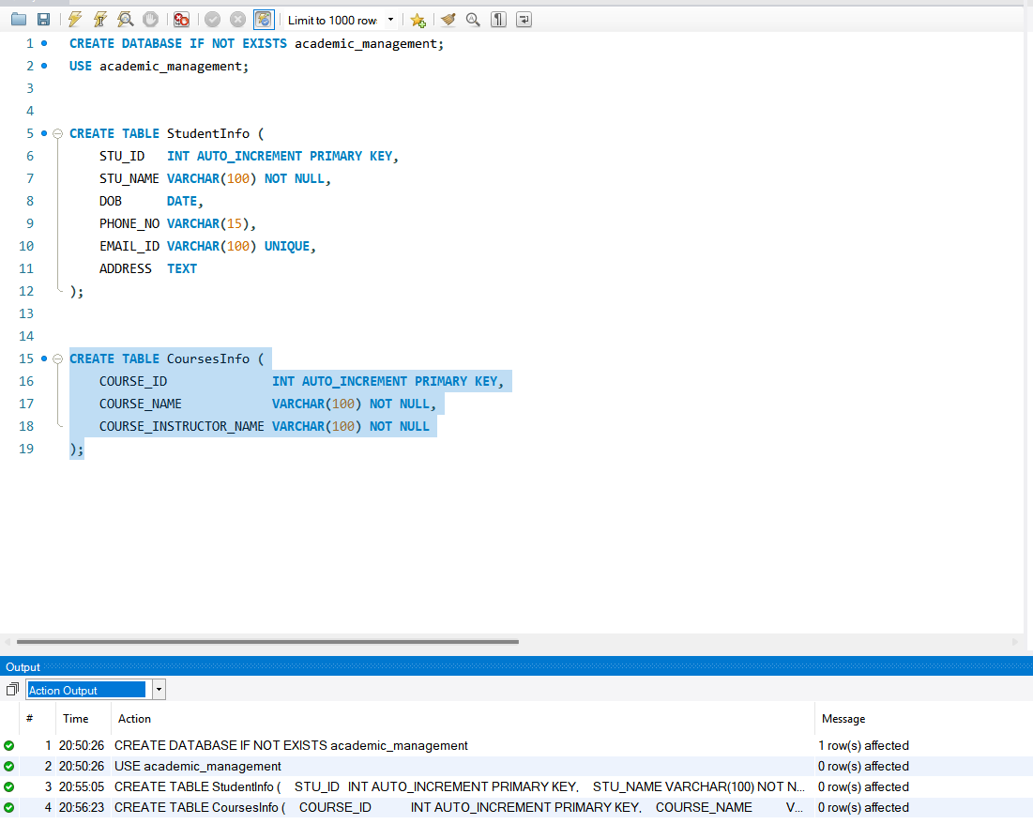

CREATE TABLE EnrollmentInfo (
ENROLLMENT_ID INT AUTO_INCREMENT PRIMARY KEY,
STU_ID INT,
COURSE_ID INT,
ENROLL_STATUS ENUM('Enrolled','Not Enrolled') DEFAULT 'Enrolled',
FOREIGN KEY (STU_ID) REFERENCES StudentInfo(STU_ID),
FOREIGN KEY (COURSE_ID) REFERENCES CoursesInfo(COURSE_ID)
);

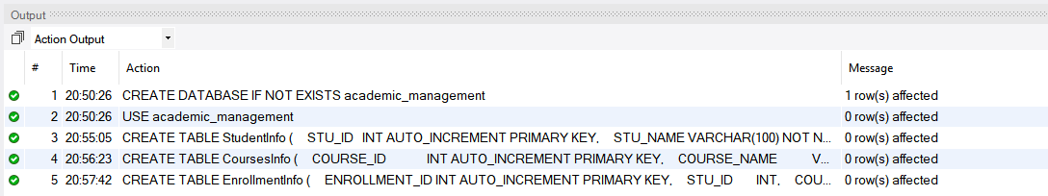

--------------------------------
-- 3. SAMPLE DATA INSERT
--------------------------------

INSERT INTO StudentInfo (STU_NAME, DOB, PHONE_NO, EMAIL_ID, ADDRESS) VALUES
('Alice Kumar', '2002-05-10', '9876543210', 'alice@example.com', 'Delhi'),
('Brian Singh', '2001-11-21', '9876500001', 'brian@example.com', 'Mumbai'),
('Chitra Rao', '2003-03-03', '9876500002', 'chitra@example.com', 'Chennai'),
('Dinesh Verma', '2002-08-15', '9876500003', 'dinesh@example.com', 'Bangalore');
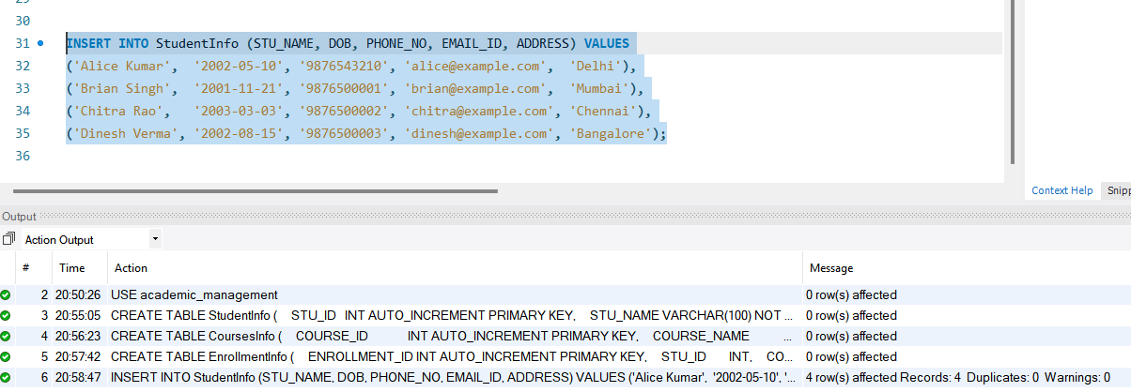
INSERT INTO CoursesInfo (COURSE_NAME, COURSE_INSTRUCTOR_NAME) VALUES
('Database Systems', 'Prof. Sharma'),
('Data Structures', 'Prof. Mehta'),
('Operating Systems', 'Prof. Iyer'),
('Computer Networks', 'Prof. Reddy');
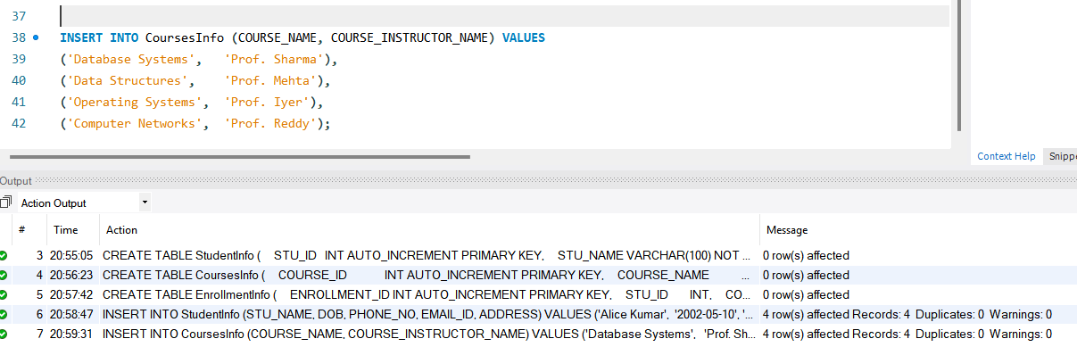
INSERT INTO EnrollmentInfo (STU_ID, COURSE_ID, ENROLL_STATUS) VALUES
(1, 1, 'Enrolled'),
(1, 2, 'Enrolled'),
(2, 1, 'Enrolled'),
(2, 3, 'Enrolled'),
(3, 2, 'Enrolled'),
(3, 4, 'Not Enrolled'),
(4, 1, 'Enrolled'),
(4, 4, 'Enrolled');

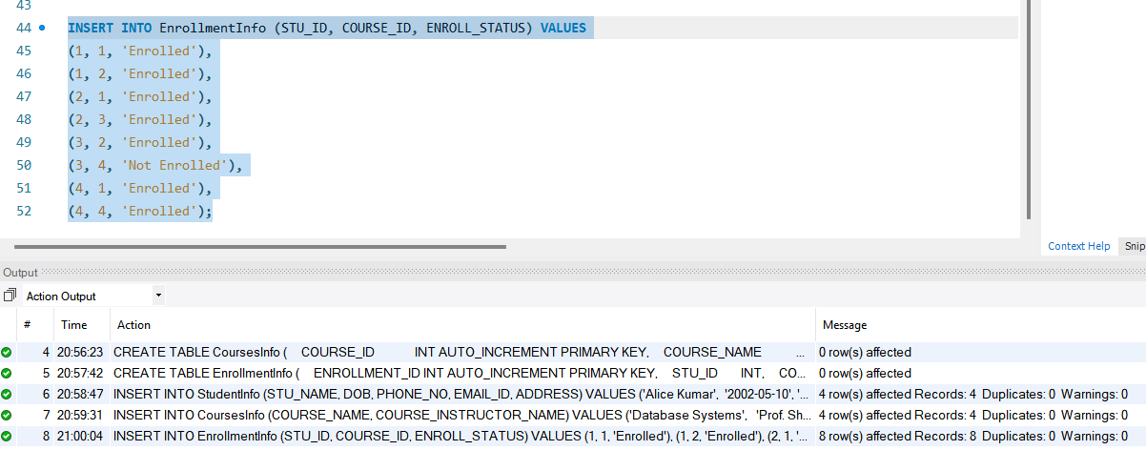

--------------------------------
-- 4. REQUIRED QUERIES
--------------------------------

-- 4a. Student details with enrollment
SELECT
s.STU_ID,
s.STU_NAME,
s.PHONE_NO,
s.EMAIL_ID,
e.COURSE_ID,
e.ENROLL_STATUS
FROM StudentInfo s
LEFT JOIN EnrollmentInfo e ON s.STU_ID = e.STU_ID
ORDER BY s.STU_ID, e.COURSE_ID;

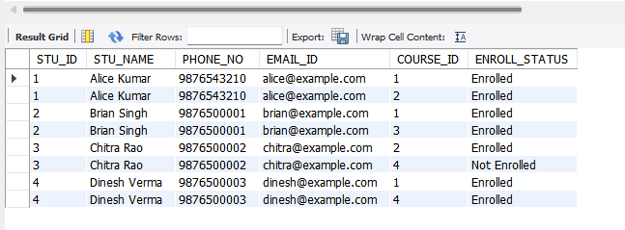

-- 4b. Courses for a specific student (example: STU_ID = 1)
SELECT
s.STU_NAME,
c.COURSE_ID,
c.COURSE_NAME,
c.COURSE_INSTRUCTOR_NAME,
e.ENROLL_STATUS
FROM EnrollmentInfo e
JOIN StudentInfo s ON e.STU_ID = s.STU_ID
JOIN CoursesInfo c ON e.COURSE_ID = c.COURSE_ID
WHERE s.STU_ID = 1
AND e.ENROLL_STATUS = 'Enrolled';
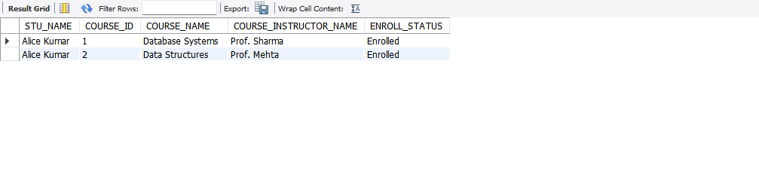
-- 4c. All course information
SELECT COURSE_ID, COURSE_NAME, COURSE_INSTRUCTOR_NAME
FROM CoursesInfo;

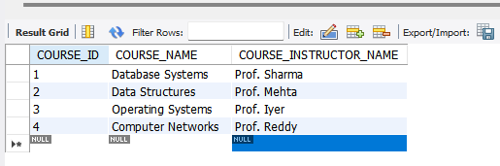

-- 4d. Info for a specific course (example: COURSE_ID = 2)
SELECT COURSE_ID, COURSE_NAME, COURSE_INSTRUCTOR_NAME
FROM CoursesInfo
WHERE COURSE_ID = 2;

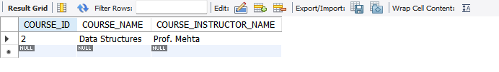

-- 4e. Info for multiple courses (example: 1, 2, 4)
SELECT COURSE_ID, COURSE_NAME, COURSE_INSTRUCTOR_NAME
FROM CoursesInfo
WHERE COURSE_ID IN (1, 2, 4);
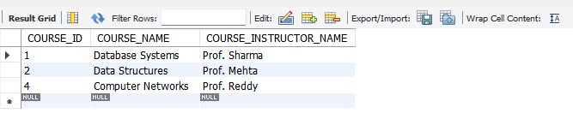
--------------------------------
-- 5. REPORTING / ANALYTICS
--------------------------------

-- 5a. Number of students enrolled in each course
SELECT
c.COURSE_ID,
c.COURSE_NAME,
COUNT(*) AS ENROLLED_STUDENTS
FROM CoursesInfo c
JOIN EnrollmentInfo e ON c.COURSE_ID = e.COURSE_ID
WHERE e.ENROLL_STATUS = 'Enrolled'
GROUP BY c.COURSE_ID, c.COURSE_NAME
ORDER BY ENROLLED_STUDENTS DESC;

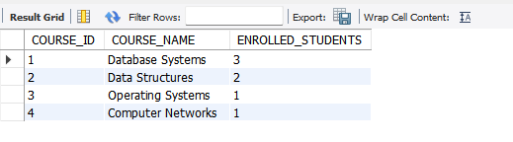

-- 5b. Students enrolled in a specific course (example: COURSE_ID = 1)
SELECT
c.COURSE_NAME,
s.STU_ID,
s.STU_NAME
FROM EnrollmentInfo e
JOIN StudentInfo s ON e.STU_ID = s.STU_ID
JOIN CoursesInfo c ON e.COURSE_ID = c.COURSE_ID
WHERE e.ENROLL_STATUS = 'Enrolled'
AND c.COURSE_ID = 1
ORDER BY s.STU_NAME;

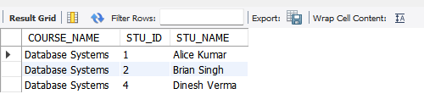

-- 5c. Count of enrolled students per instructor
SELECT
c.COURSE_INSTRUCTOR_NAME,
COUNT(DISTINCT e.STU_ID) AS ENROLLED_STUDENTS
FROM CoursesInfo c
JOIN EnrollmentInfo e ON c.COURSE_ID = e.COURSE_ID
WHERE e.ENROLL_STATUS = 'Enrolled'
GROUP BY c.COURSE_INSTRUCTOR_NAME
ORDER BY ENROLLED_STUDENTS DESC;
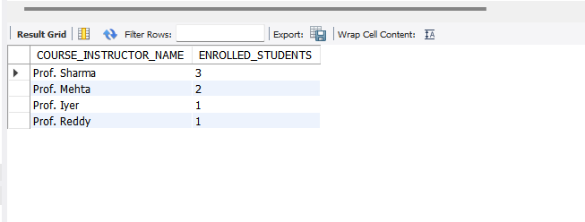
-- 5d. Students enrolled in multiple courses
SELECT
s.STU_ID,
s.STU_NAME,
COUNT(DISTINCT e.COURSE_ID) AS COURSE_COUNT
FROM StudentInfo s
JOIN EnrollmentInfo e ON s.STU_ID = e.STU_ID
WHERE e.ENROLL_STATUS = 'Enrolled'
GROUP BY s.STU_ID, s.STU_NAME
HAVING COUNT(DISTINCT e.COURSE_ID) > 1
ORDER BY COURSE_COUNT DESC;
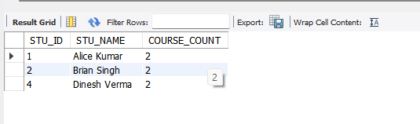
-- 5e. Courses with highest enrollment
SELECT
c.COURSE_ID,
c.COURSE_NAME,
COUNT(*) AS ENROLLED_STUDENTS
FROM CoursesInfo c
JOIN EnrollmentInfo e ON c.COURSE_ID = e.COURSE_ID
WHERE e.ENROLL_STATUS = 'Enrolled'
GROUP BY c.COURSE_ID, c.COURSE_NAME
ORDER BY ENROLLED_STUDENTS DESC;

